

UNIVERSITY OF BUEA
FACULTY OF ENGINEERING AND TECHNOLOGY
DEPARTMENT OF COMPUTER ENGINEERING
CEF440: INTERNET PROGRAMMING AND MOBILE PROGRAMMING

PROJECT TITLE: DESIGN AND IMPLEMENTATION OF AN ADAPTIVE E-LEARNING PLATFORM BASED ON QUALITY OF EXPERIENCE FOR INCLUSIVE ONLINE EDUCATION IN LOW – RESOURCE SETTINGS.

TASK 3
Group 15 Report
COURSE INSTRUCTOR: Dr Nkemeni Valery

NAME | MATRICULE
NJINYA NGECHA RYAN BROWN | FE23A116
KARL JONAS WENGE ACHA | FE23A072
BRIANNA TEBESICK TSAMO | FE23A028
KELSEY NJOCK-AWOH NJOCK OBEN | FE23A073

10th May 10, 2026

Table of Contents
INTRODUCTION 3
OVERVIEW OF TASK 3 RESULTS 4
ANALYSIS OF SURVEY FINDINGS 5
Learners Mostly Use Smartphones 5
Most Learners Use Android Devices 6
Many Learners Depend on Mobile Data 6
Power Outages Affect Learning 7
Learners Prefer Multimedia Learning Content 8
Poor Network Quality and High Data Consumption Affect E-learning 9
Learners Want Interaction with Lecturers 9
Parents Want Progress Tracking 10
School Administrators Value Attendance and Progress Tracking 11
School Administrators Want Offline Content 12
Instructors Experience Network Challenges 12
Instructors Want Recording and Live Chat Features 13
Instructors Want Online Quizzes and Attendance Tracking 14
Instructors use laptops for online teaching 15
PRIORITIZATION OF REQUIREMENTS 18
CLASSIFICATION OF REQUIREMENTS 20
Functional Requirements 20
Non-functional Requirements 21
SOFTWARE REQUIREMENTS SPECIFICATION 22
INTRODUCTION 22
Purpose 22
Scope 22
Objectives 22
System Overview 22
Description of the Platform 22
Stakeholders 23
Major Features 23
Functional Requirements 23
Non-Functional Requirements 24
Constraints 24
Assumptions 26
REQUIREMENT VALIDATION 28
CONCLUSION 29

INTRODUCTION
This report presents the requirement analysis phase for the project entitled “Design and Implementation of an Adaptive E-learning Platform based on Quality of Experience for Inclusive Online Education in Low-resource Settings.”

The purpose of this phase is to analyse the data gathered from stakeholders during Task 2, identify user needs, classify system requirements, prioritize important features, develop a Software Requirement Specification (SRS) for the proposed system, validate the requirements with stakeholders and identify the type of application we are going to build.

Data collected through surveys, observations, brainstorming, and reverse engineering techniques were analysed to determine the functional and non-functional requirements of the platform.

OVERVIEW OF TASK 3 RESULTS
Task 3 focused on gathering requirements for the proposed adaptive e-learning platform based on Quality of Experience (QoE) for inclusive online education in low-resource settings. The aim was to understand the challenges faced by stakeholders during online learning and identify the features and system requirements needed to improve the learning experience in environments with limited resources.
The participants involved in the data collection process included learners, instructors, parents, and school administrators. These groups were selected because they are the main stakeholders involved in the use and management of e-learning systems. Learners provided information about their learning experiences, challenges, and preferred learning methods. Instructors shared their teaching challenges and desired teaching features, while parents and school administrators provided insights into supervision, monitoring, infrastructure, and system management needs.
Several requirement gathering techniques were used during Task 2. Surveys were the primary method used to collect data from participants because they made it possible to gather responses from different stakeholder groups efficiently. Brainstorming sessions were also carried out within the project team to identify possible system features and solutions. In addition, reverse engineering was used to study existing e-learning platforms and understand the features they provide as well as the limitations they have in low-resource settings.
After data collection, the responses obtained from the surveys were cleaned to improve accuracy before analysis. This ensured that the final dataset used for analysis was reliable and suitable for deriving system requirements and stakeholder needs.

Following the data cleaning process, charts and graphical representations were generated from the survey responses. These charts helped visualize participant responses and made it easier to identify patterns, trends, and major challenges affecting online learning in low-resource settings. The generated charts also supported the interpretation of the results and the extraction of both functional and non-functional system requirements for the proposed platform in task 3.

ANALYSIS OF SURVEY FINDINGS
The charts presented below are some of the graphical representations generated from the survey responses collected during the requirement gathering phase of the project. These charts were used to visualize stakeholder opinions, identify common challenges experienced in online learning environments, and highlight the most important features expected from the proposed adaptive e-learning platform. The analysis of these findings helped in deriving both functional and non-functional requirements necessary for improving the quality of experience in low-resource settings.

Learners Mostly Use Smartphones
Finding:
The survey results showed that most learners use smartphones to access online learning platforms.
Chart:
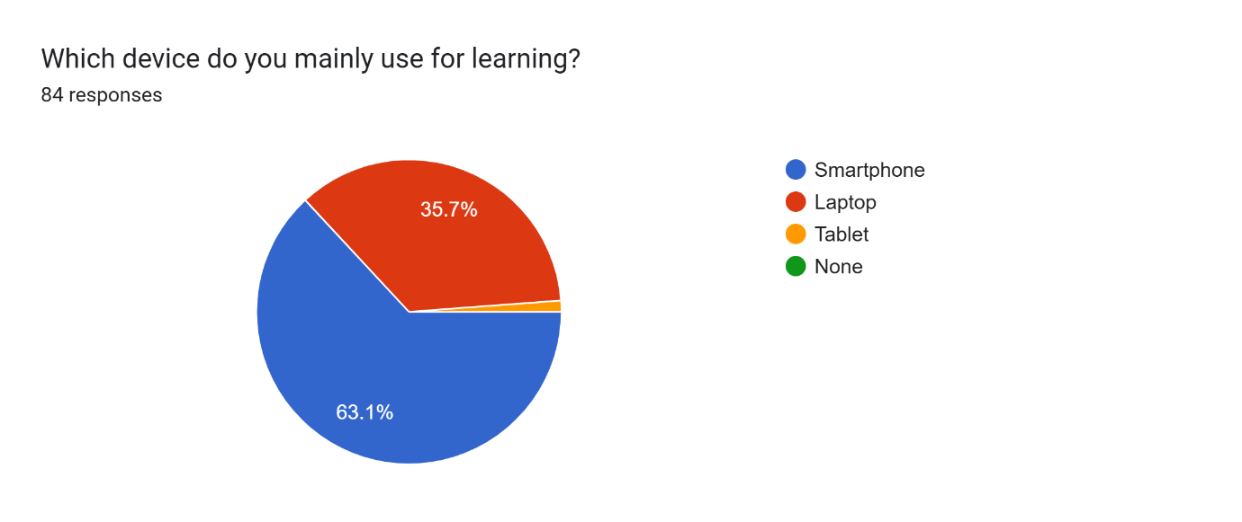
Explanation:
This shows that mobile devices are the primary means through which learners access online education. Since smartphones are more accessible and affordable in low-resource settings, the system must prioritize mobile accessibility and usability.
Requirement:
The system should provide a mobile-friendly and responsive interface optimized for smartphone usage.

Most Learners Use Android Devices
Finding:
Most respondents indicated that they use Android devices for online learning.
Chart:
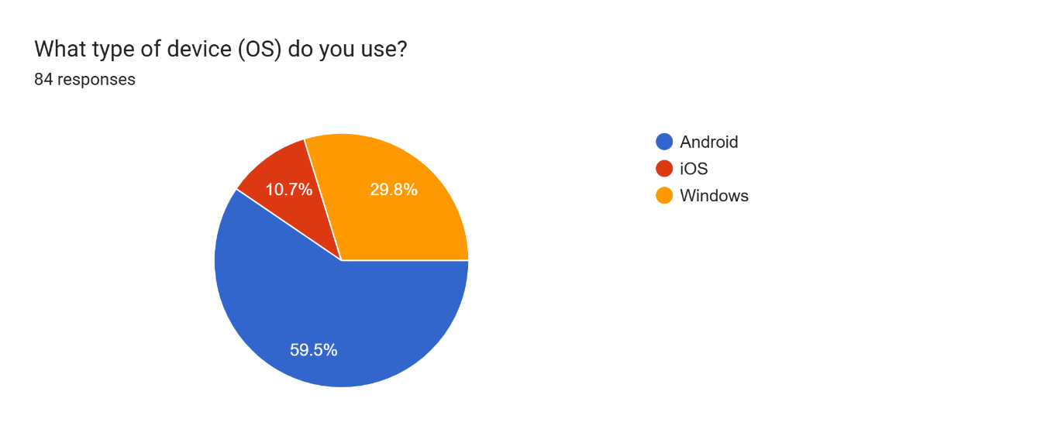
Explanation:
Android devices are the most commonly available devices among learners in low-resource environments. This means the platform should function effectively on Android phones with different screen sizes and hardware capabilities.
Requirement:
The system should be compatible with Android devices and support low-end smartphones.

Many Learners Depend on Mobile Data
Finding:
46.4% of learners use both Wi-Fi and mobile data, while 41.7% rely only on mobile data.
Chart:
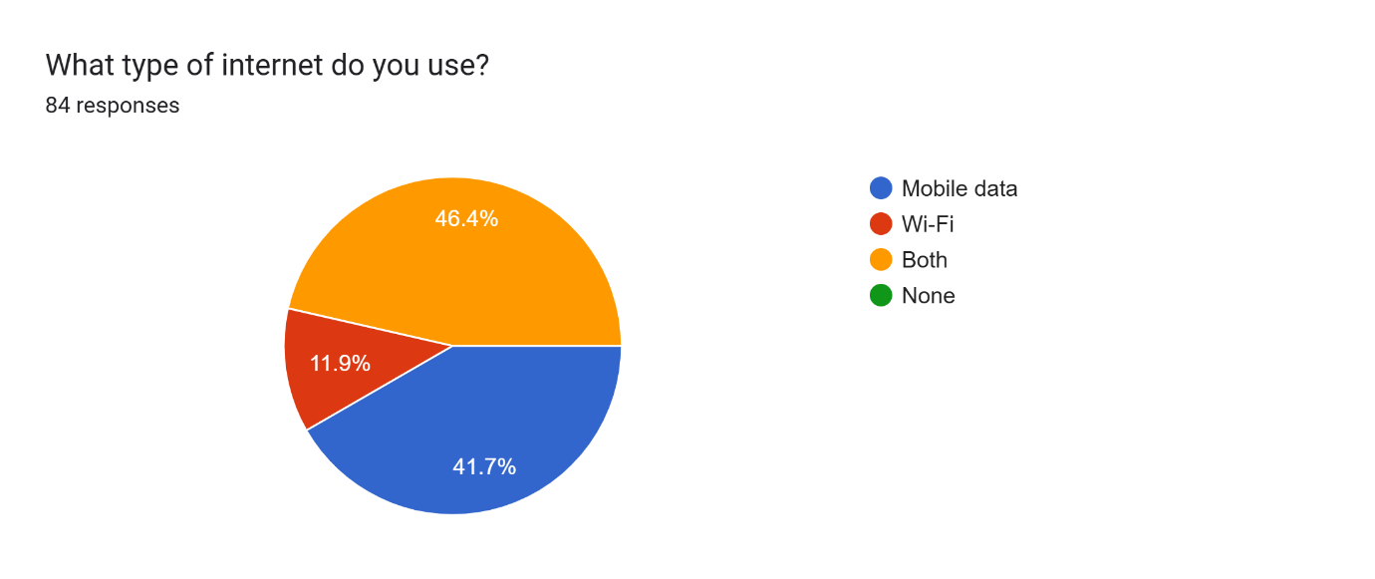
Explanation:
This indicates that many learners depend heavily on mobile internet, which is often expensive and unstable. High data usage may discourage continuous participation in online learning activities.
Requirement:
The system should optimize bandwidth and minimize data consumption during content delivery.

Power Outages Affect Learning
Finding:
Most learners reported that power outages negatively affect their online learning experience.
Chart:
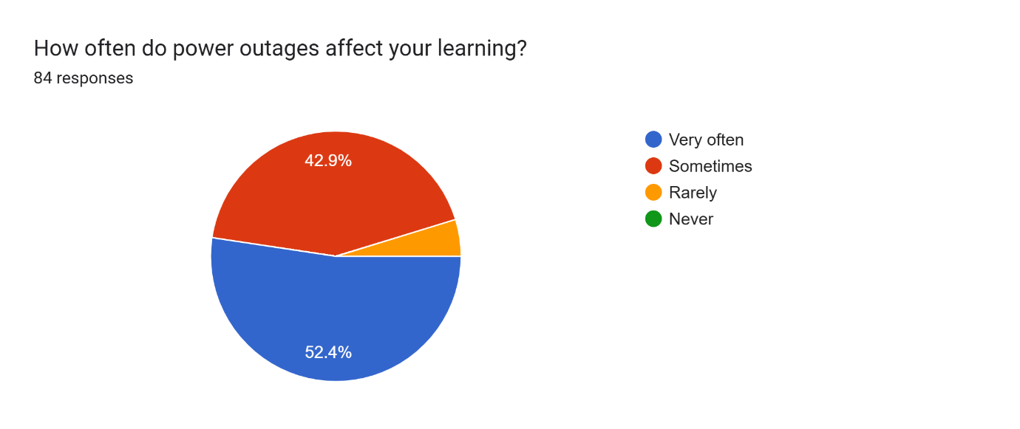
Explanation:
Frequent power interruptions can disconnect learners during lessons and prevent continuous participation. This is a major challenge in low-resource settings where electricity supply may be unreliable.
Requirement:
The system should support offline access and allow learners to continue from where they stopped after interruptions.

Learners Prefer Multimedia Learning Content
Finding:
51.8% of learners prefer a combination of video, audio, and text content during online learning.
Chart:
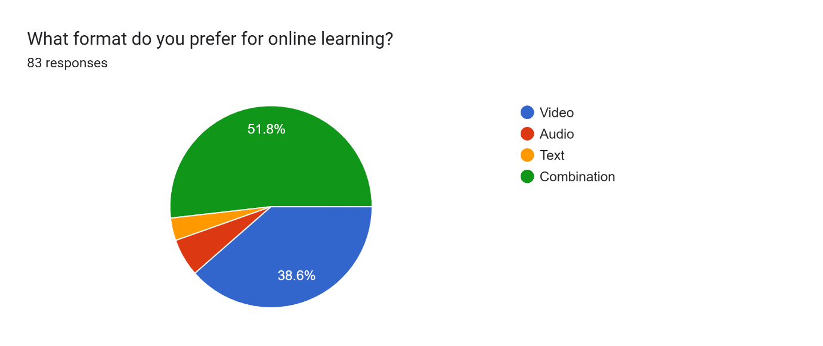
Explanation:
Different learners understand content better using different formats. Providing multiple content formats can improve engagement, understanding, and inclusiveness.
Requirement:
The system should support multimedia content including video, audio, and text-based materials.

Poor Network Quality and High Data Consumption Affect E-learning
Finding:
Most learners identified unstable internet and cost of data as major challenges in online learning.
Chart:
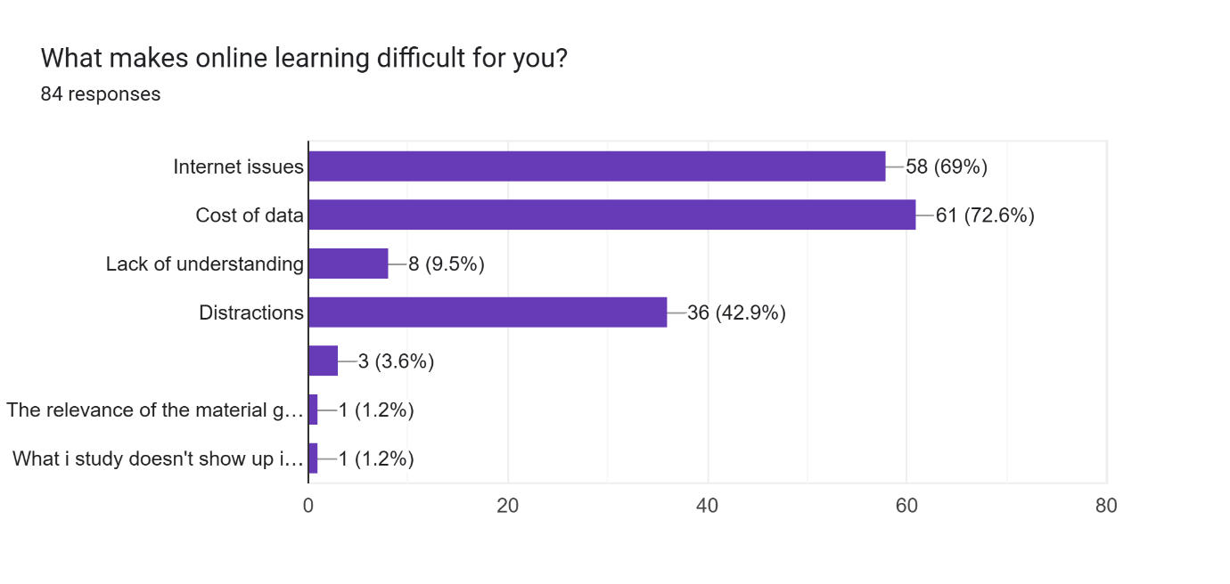
Explanation:
Poor connectivity reduces the quality of online lessons and may prevent learners from participating effectively. High data costs also limit access to educational content.
Requirement:
The system should function effectively under low-bandwidth conditions and provide adaptive content delivery.

Learners Want Interaction with Lecturers
Finding:
Most learners expressed interest in interacting with lecturers during online learning.
Chart:
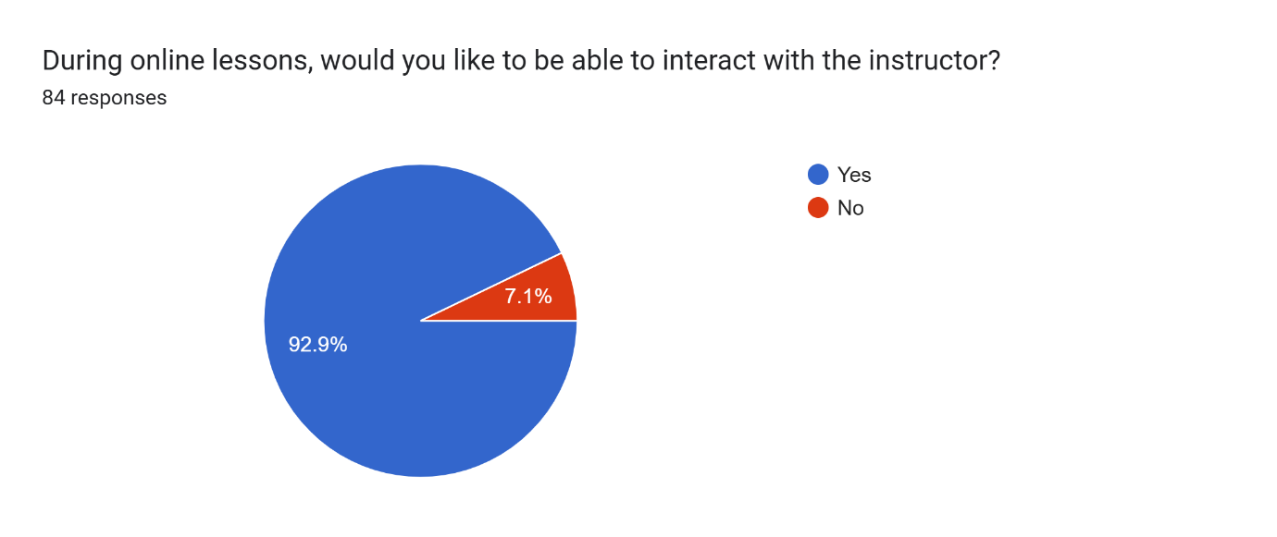
Explanation:
Interaction improves learner engagement and helps students clarify difficult concepts during lessons.
Requirement:
The system should provide live chat, discussion, and question-and-answer features.

Parents Want Progress Tracking
Finding:
Most parents indicated that they would like to track their children’s learning progress.
Chart:
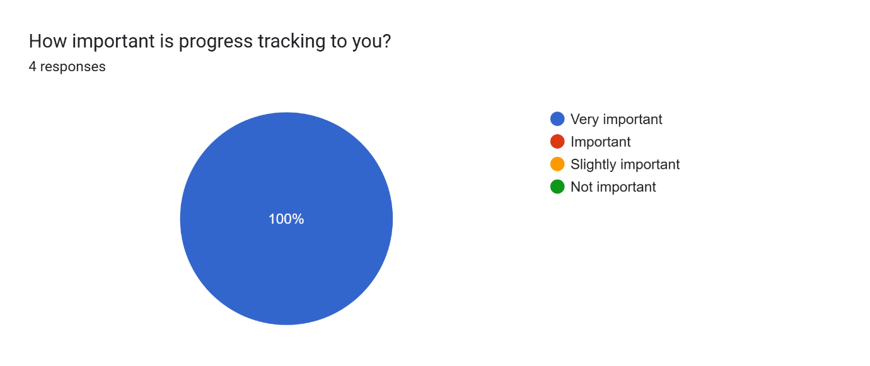
Explanation:
Parents want visibility into their children’s participation and performance in online learning activities.
Requirement:
The system should provide learner progress tracking and monitoring features accessible to parents.

School Administrators Value Attendance and Progress Tracking
Finding:
Most school administrators considered attendance, participation, and progress tracking as the most important features.
Chart:
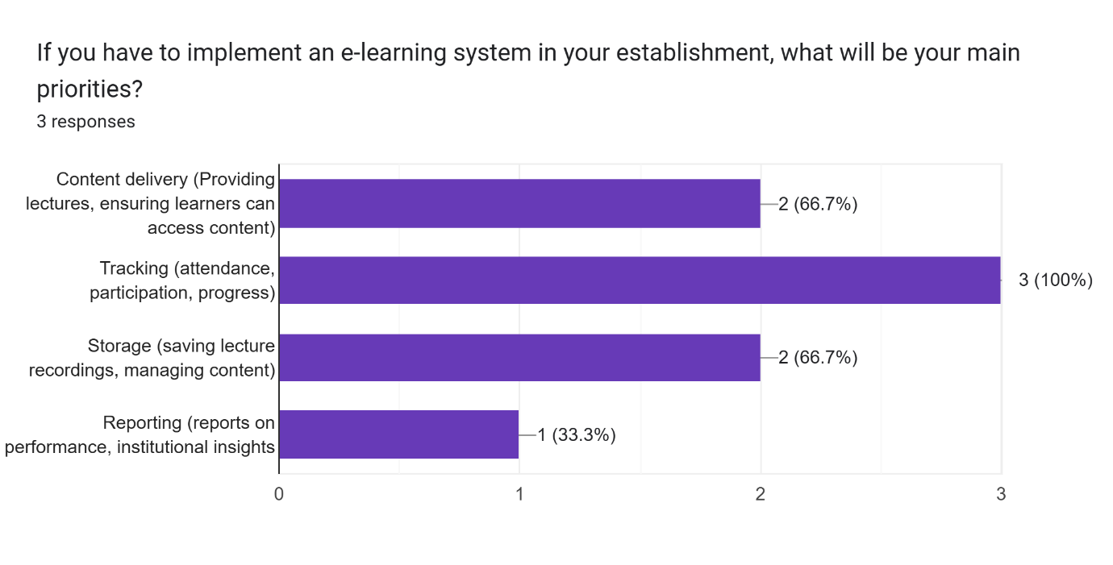
Explanation:
Administrators require monitoring tools to supervise academic activities and evaluate learner engagement.
Requirement:
The system should provide attendance, participation, and progress tracking functionalities.

School Administrators Want Offline Content
Finding:
All school administrators indicated interest in offline content and recorded lessons.
Chart:
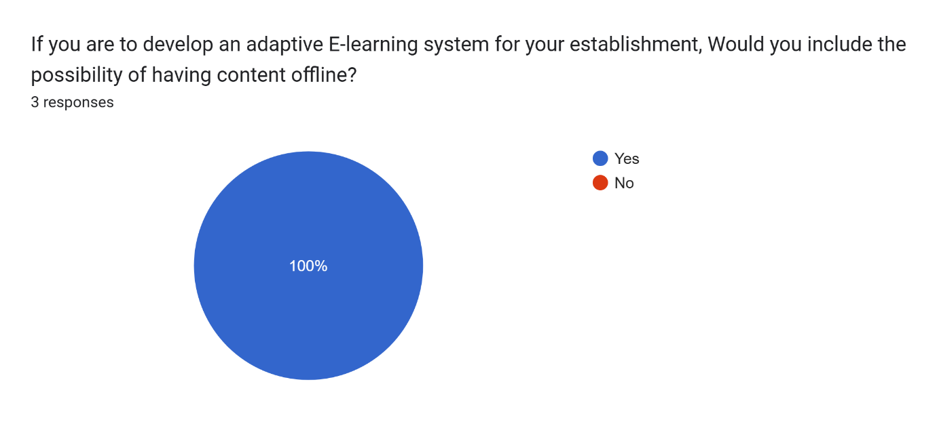
Explanation:
Offline learning support is important in environments with unstable internet connectivity.
Requirement:
The system should support downloadable and offline-accessible learning materials.

Instructors Experience Network Challenges
Finding:
Most instructors identified poor network quality as their biggest challenge during online teaching.

Chart: 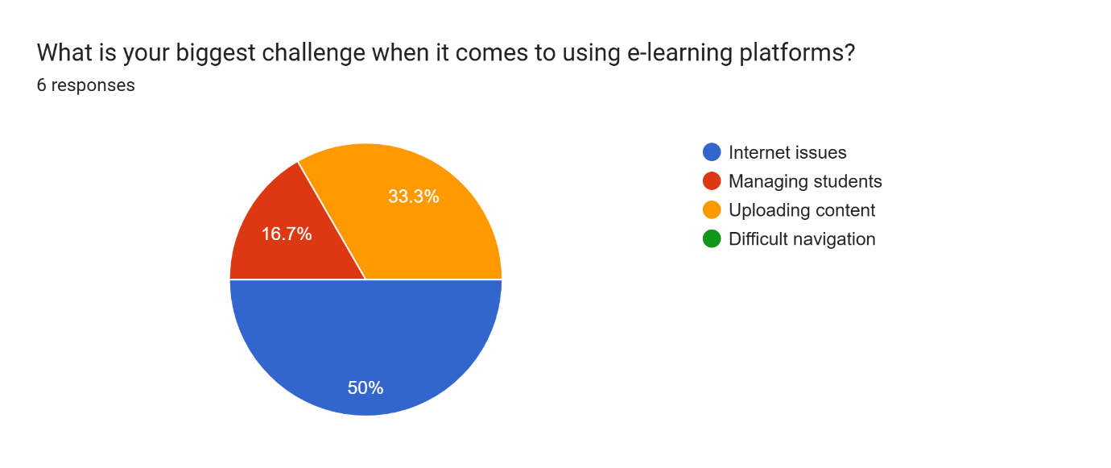
Explanation:
Unstable internet affects lesson delivery, communication, and learner participation during online classes.
Requirement:
The system should maintain acceptable performance under poor network conditions.

Instructors Want Recording and Live Chat Features
Finding:
Most instructors indicated that lesson recording and live chat would help them teach more effectively.
Chart:
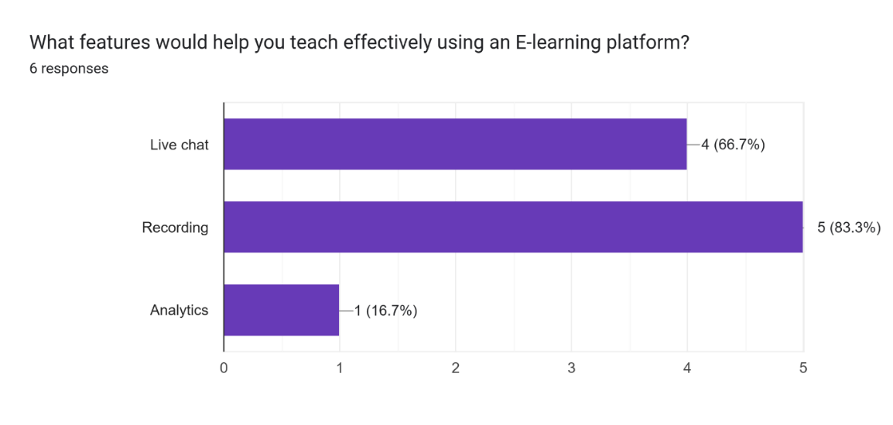
Explanation:
Recorded lessons allow learners to revisit content, while live chats improve communication and engagement during lessons.
Requirement:
The system should provide lesson recording and real-time communication features.

Instructors Want Online Quizzes and Attendance Tracking
Finding:
All instructors expressed interest in online quizzes, while most also wanted attendance tracking features.
Chart:
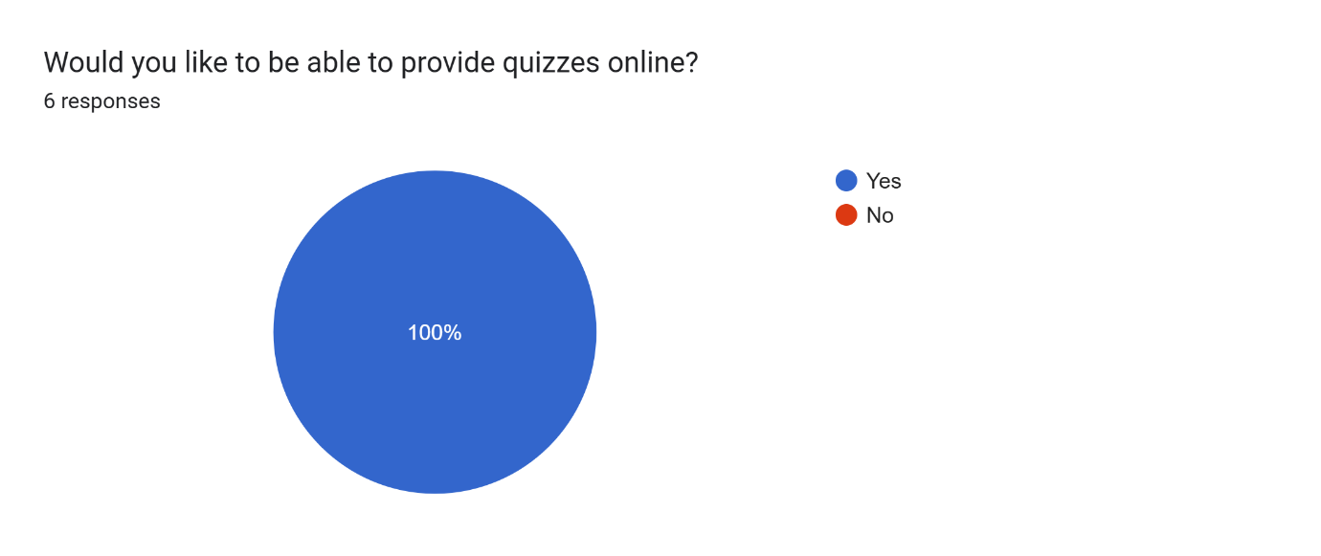
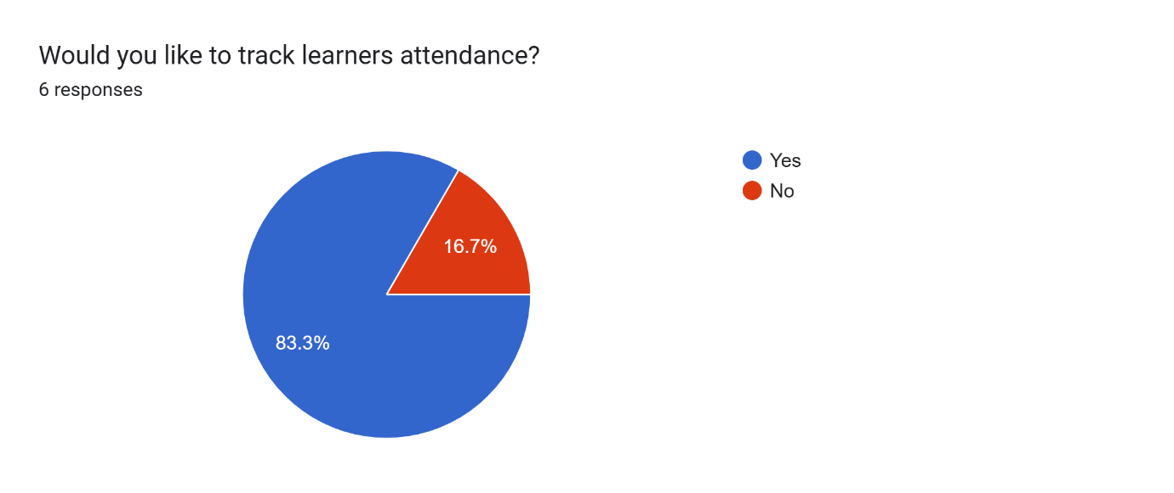
Explanation:
Assessment and attendance monitoring are important for evaluating learner participation and understanding.
Requirement:
The system should support online quizzes, assessments, and attendance tracking.

Instructors use laptops for online teaching
Finding: Most instructors use laptops for online teaching.

Chart:
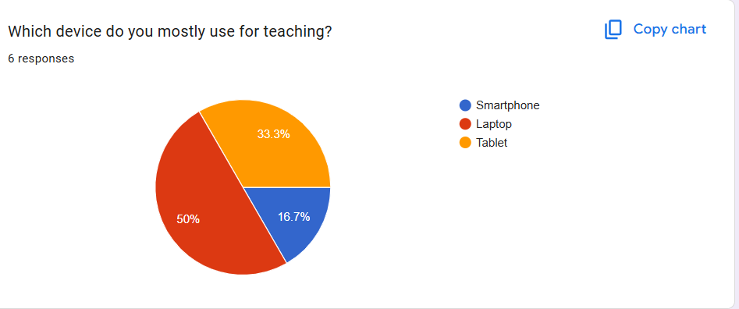

Explanation:
This shows that laptops are the primary means through which instructors provide online education. Since laptops make it easy for instructors to teach, manage students and upload course contents.

Requirement:
The system should provide a responsive interface optimized for laptop and desktop usage.
Below is a table showing all the findings, their explanations and the requirement from each finding.

Finding | Explanation of Finding | Requirement
Most learners use smartphones. | Learners mainly depend on smartphones for accessing online education platforms. | The system should provide a mobile-friendly and responsive interface.
Most learners use Android devices. | Android devices are the most accessible devices among learners in low-resource settings. | The system should support Android devices, including low-end smartphones.
Many learners depend on mobile data. | High data costs and unstable internet affect learner participation. | The system should minimize data consumption and optimize bandwidth usage.
Power outages affect learning. | Electricity interruptions disrupt online learning activities. | The system should support offline access and progress recovery after interruptions.
Learners prefer multimedia learning content. | Different learners understand content better using different formats. | The system should support video, audio, and text-based learning materials.
Poor network quality affects e-learning. | Unstable internet reduces the effectiveness of online learning. | The system should function effectively under low-bandwidth conditions.
Learners want interaction with lecturers. | Interaction improves engagement and understanding during lessons. | The system should provide live chat and discussion features.
Parents want progress tracking. | Parents want to monitor their children’s learning activities and performance. | The system should provide learner progress tracking features.
School administrators value attendance and progress tracking. | Administrators require monitoring tools for academic supervision. | The system should support attendance, participation, and progress tracking.
School administrators want offline content. | Offline access is important in low-resource environments with unstable internet. | The system should support downloadable and offline-accessible content.
Instructors experience network challenges. | Poor internet quality affects lesson delivery and communication. | The system should maintain acceptable performance under poor network conditions.
Instructors want pre-recording, recording and live chat features. | These features improve communication and allow learners to revisit lessons. | The system should provide lesson recording and real-time communication features.
Instructors want quizzes and attendance tracking. | Assessment and attendance monitoring are important for evaluating learner participation. | The system should support quizzes, assessments, and attendance tracking.

PRIORITIZATION OF REQUIREMENTS
This section presents requirements prioritized based on importance to users, technical feasibility, and project scope constraints. The aim is to ensure a realistic implementation within a limited time frame while still covering all core functionalities of an adaptive e-learning system for low-resource settings.
Requirement | Importance | Feasibility | Priority
User authentication and role-based access (Learner, Instructor, Admin, Parent) | High | High | Must-have
Mobile-friendly and responsive interface | High | High | Must-have
Course/content upload and management | High | High | Must-have
Recorded lessons (video/audio/text materials) | High | Medium | Must-have
Online quizzes and assessments | High | High | Must-have
Attendance and progress tracking system | High | Medium | Must-have
Offline downloadable learning materials | High | Medium | Must-have
Low-bandwidth optimization (data saving mode) | High | Medium | Must-have
Live video classes (basic implementation) | High | Low | Should-have (simplified)
Live chat / Q&A during lessons | Medium | Medium | Should-have
Lecturer rating and feedback system | Medium | High | Should-have
Parent monitoring dashboard | Medium | Medium | Should-have
Advanced QoE-based adaptive streaming (auto quality switching) | High | Low | Nice-to-have
Real-time reconnection during live sessions | Medium | Low | Nice-to-have

The system focuses first on core learning functionality such as authentication, content delivery, quizzes, and tracking. Features that are critical for low-resource environments (offline mode, low data usage) are treated as Must-have requirements.
Live video classes are included but treated as a simplified implementation due to time and technical constraints. Advanced adaptive QoE features are classified as Nice-to-have because they are complex and may exceed the implementation window.

CLASSIFICATION OF REQUIREMENTS
Here, we classified the identified system requirements into functional and non-functional requirements based on their nature and role in the system. Functional requirements describe what the system should do, while non-functional requirements describe how the system should perform.

Functional Requirements
These are the requirements that define what the system should do in terms of features and services.
- The system should allow users to register, log in, and access the platform based on their roles (learner, instructor, parent, administrator).
- The system should provide role-based access control for different user categories.
- The system should allow instructors to upload and manage learning content.
- The system should provide learners with access to video, audio, text, and slide-based learning materials.
- The system should support recorded lessons that learners can access at any time.
- The system should provide online quizzes and assessments for learners.
- The system should track learner attendance during sessions or system usage.
- The system should track instructor attendance.
- The system should track learner progress based on activities and assessments.
- The system should allow live classes for real-time teaching and learning.
- The system should provide live chat and question-and-answer features during lessons.
- The system should allow learners to rate and give feedback on instructors.
- The system should provide parents with access to monitor learner progress.
- The system should generate reports for administrators on attendance, performance, and engagement.

Non-functional Requirements
- The system should be mobile-friendly and optimized for smartphone usage.
- The system should be compatible with Android devices, including low-end smartphones.
- The system should be optimized for low-bandwidth environments and unstable internet connections.
- The system should minimize data consumption during content delivery.
- The system should support offline access through downloadable learning materials.
- The system should ensure system reliability and availability in low-resource settings.
- The system should provide fast loading times (< 5 seconds) and responsive user interaction.
- The system should ensure usability for users with low digital literacy.
- The system should support adaptive content delivery based on network conditions.
- The system should ensure data security and restrict access based on user roles.

SOFTWARE REQUIREMENTS SPECIFICATION

INTRODUCTION

Purpose
The purpose of this Software Requirement Specification (SRS) is to define the functional and non-functional requirements of an adaptive e-learning platform based on Quality of Experience (QoE) for inclusive online education in low-resource settings. This document provides a clear description of what the system is expected to do and the constraints under which it will operate.

Scope
This system is designed to support online learning for learners, instructors, parents, and school administrators in environments with limited resources such as unstable internet, power outages, and limited access to digital devices. The platform will provide learning content delivery, interaction tools, assessments, progress tracking, and adaptive features to improve user experience.

Objectives
The main objectives of the system are to improve accessibility to education, enhance learner engagement, support instructors in delivering content effectively, and enable administrators and parents to monitor learning activities. The system also aims to optimize learning under low-resource conditions through adaptive content delivery and offline capabilities.

System Overview

Description of the Platform
The proposed system is a web-based adaptive e-learning platform that delivers educational content in multiple formats such as video, audio, and text. It is designed to adjust to network conditions and provide offline learning capabilities to ensure continuity in low-resource environments.

Stakeholders
The main stakeholders of the system include:
- Learners
- Instructors
- Parents
- School administrators

Major Features
The system will include features such as user authentication, role-based access, course content management, live and recorded lessons, quizzes and assessments, attendance tracking, progress monitoring, communication tools, and adaptive content delivery based on network conditions.

Functional Requirements
- The system should allow users to register, log in, and access the platform based on assigned roles.
- The system should implement role-based access control for learners, instructors, parents, and administrators.
- The system should allow instructors to upload and manage learning content.
- The system should provide learners with access to video, audio, text, and slide-based learning materials.
- The system should support recorded lessons that can be accessed offline or online.
- The system should provide online quizzes and assessments for learners.
- The system should track learner attendance and participation in learning activities.
- The system should track instructor attendance.
- The system should monitor learner progress based on activities and assessments.
- The system should support live classes for real-time teaching and learning.
- The system should provide live chat and question-and-answer functionality during lessons.
- The system should allow learners to rate and give feedback on instructors.
- The system should provide parents with access to learner progress information.
- The system should generate reports for administrators on attendance, performance, and engagement.

Non-Functional Requirements
- The system should be mobile-friendly and optimized for smartphones.
- The system should be compatible with Android devices, including low-end devices.
- The system should operate efficiently under low-bandwidth and unstable network conditions.
- The system should minimize data consumption during content delivery.
- The system should support offline access to learning materials.
- The system should ensure high system reliability and availability.
- The system should provide fast response time and smooth user interaction.
- The system should be easy to use for users with different levels of digital literacy.
- The system should ensure data security through authentication and role-based access control.
- The system should support scalability for multiple users accessing the platform simultaneously.

Constraints
- Network Constraints.
- The system must operate effectively under low bandwidth and unstable internet conditions common in low-resource environments.
- The system must support intermittent connectivity including partial offline functionality
- Real-time adaptation must work even with fluctuating network speeds.
- Device Constraints
- The system must be optimized for low-end Android smartphones.
- The system must also support laptops used by instructors
- The interface must be responsive and lightweight, minimizing memory and processing usage.
- Performance Constraints.
- The system must ensure fast loading times, even on slow networks.
- Multimedia content must be compressed and optimized to reduce data usage.
- Real-time adaptation based on network conditions must not introduce significant delays.
- Usability Constraints
- The platform must be usable by individuals with varying levels of digital literacy.
- The user interface must be simple, intuitive, and mobile-friendly.
- Content Constraints
- The system must support multiple content formats while ensuring they are suitable for low-resource environments.
- Uploaded content must be optimized or compressed automatically or manually before delivery.
- Technological Constraints.
- The system must be built as a Progressive Web App (PWA). Because learners primarily use smartphones with limited storage space and instructors use laptops, a PWA provides a single adaptable codebase. Furthermore, it bypasses large app store downloads to save device memory and utilizes browser caching to support the required offline access during power outages.
- The system must utilize React for the frontend user interface. React’s lightweight, Virtual DOM architecture is essential to minimize memory and processing usage, ensuring the application remains fast and responsive on the low-end Android smartphones predominantly used by learners.
- The system must use Express.js running on the Node.js runtime environment. This asynchronous, event-driven architecture is required to efficiently handle the system's real-time features, such as live chat and question-and-answer interactions, without failing under low-bandwidth network conditions.
- The system must use PostgreSQL (and SQL). Structured relational data management is necessary to securely implement the required role-based access control (Learners, Instructors, Parents, Admins) and accurately track learner attendance and academic progress.

Assumptions
- User Assumptions
- Users have basic digital literacy, including the ability to navigate web platforms and mobile apps.
- Users will interact with the platform individually. That is, no shared accounts.
- Device Assumptions
- Learners will access the system using smartphones
- Instructors will primarily use laptops.
- User devices support modern web browsers capable of rendering multimedia content.
- Connectivity Assumptions
- Users will have at least occasional internet access, even if it is unstable.
- Network speed may vary, but it will be sufficient at times to allow content synchronization and updates.
- Content Assumptions
- Instructors will upload relevant and structured learning materials.
- Instructors will follow recommended formats to ensure compatibility and optimization.
- System Usage Assumptions
- Users will engage with the platform regularly enough for the system to adapt content delivery effectively.
- Real-time adaptation based on network conditions will improve user experience (QoE).

REQUIREMENT VALIDATION
Requirement validation was carried out to ensure that the identified requirements accurately reflected the needs of the stakeholders and aligned with the objectives of the proposed adaptive e-learning platform. The validation process helped confirm that the requirements were understandable, realistic, relevant, and suitable for low-resource educational environments.
To validate the requirements, a summarized list of the identified functional and non-functional requirements was presented to selected stakeholders, including learners, instructors, and school administrators. The stakeholders reviewed the requirements and provided feedback on whether the proposed features addressed their challenges and expectations regarding online learning in low-resource settings.
During the validation process, stakeholders confirmed the importance of features such as offline learning support, recorded lessons, low-bandwidth optimization, quizzes, attendance tracking, and interaction tools. Additional clarifications were also obtained for some
requirements that were initially too broad or unclear. This helped improve the quality and accuracy of the final requirements specification.
The requirements were verified by checking whether each requirement was consistent with the survey findings and project objectives. Requirements were also reviewed to ensure that they were clear, feasible, and implementable within the scope of the project. Duplicate and conflicting requirements were removed, while vague requirements were refined into more specific and measurable statements.
Overall, the validation and verification process helped ensure that the final requirements accurately represented stakeholder needs and provided a solid foundation for the design and implementation of the adaptive e-learning platform.

CONCLUSION
In this task, we successfully reviewed, analyzed, prioritized, and validated the system requirements for the proposed Quality of Experience (QoE) driven adaptive e-learning platform. By evaluating survey feedback from learners, instructors, parents, and school administrators, we identified the critical barriers affecting online education in low-resource settings—namely poor network quality, high data consumption, frequent power outages, and limited device capabilities.
To directly address these challenges, stakeholders prioritized essential system features, including offline learning support, adaptive content delivery, recorded and live lessons, attendance tracking, and seamless instructor-learner interaction. These findings established a clear baseline for both our functional and non-functional requirements.
Technologically, we concluded that a Progressive Web App (PWA) is the optimal architecture for this system. Unlike native or hybrid applications, a PWA provides a single, highly adaptable codebase that serves both mobile users (predominantly on Android smartphones) and instructors on laptops. Crucially, it bypasses heavy app store downloads to conserve limited device storage and leverages browser caching to guarantee access to learning materials during network or power failures. This architecture will be powered by a lightweight React frontend, a responsive Node.js and Express backend, and a secure PostgreSQL database for comprehensive data management.
Overall, the requirement analysis conducted in this task successfully translated stakeholder needs into clear, actionable technical specifications. These validated requirements and defined technological constraints now establish a strong, feasible foundation for the upcoming design and implementation phases of the platform.

